**Manual for Internal Outgoing Students**

**The application process is divided into two parts:  OUTGOING (the student “going out” from their institution) and INCOMING (the student “coming in” their exchange destination)**.

**Outgoing (part 1):** The student goes to system and fills in the Registration Form, Creates an Account and Uploads Documents in the Outgoing Application Workflow. Then the International Relations Officer (IRO) can officially nominate the student for the exchange with the partner institution(s). Only once the nomination has been confirmed and the first part of the application is imported by the destination/s, the student will be able to complete the Incoming part of the application.

**Incoming (part 2):** The students upload the relevant documents and recordings in the Incoming Workflow. If the student applies for an to multiple institutions, they will have to upload the documents in the workflows of each destination. For institutions not using EASY MO, a different procedure might apply. The student will be informed about that.

**Please note that the application is a multiple step process. So please start your application well before the application deadline at the destinations.** Only if you complete all steps you will be able to submit your application. Please keep an eye on the mailbox of the email address you provide when registering in the system in order to know the next steps of the application process.

**Part 1: Outgoing**

Step 1: Please go to <https://mobility.aec-music.eu/LoginServlet>, click on **Become an applicant** and chose your country and home institution. Then, click on enter application.

Step 2: You can now start filling **the Outgoing Registration Form.**

The outgoing registration form asks for information regarding your planned exchange, such as the academic year when the mobility will take place and asks you to choose **up to 4 destinations.** If you want to apply to moredestinations, please check with your international office if this is possible. If yes, you will need to fill in a second registration form.

You can apply for the exchange as long as the Outgoing application period of your home institution is open, regardless of if the Incoming application period is still closed or not, BUT – if the application deadline of one of the destinations has already expired, you will get a warning message when filling in the form and that destination cannot be selected and therefore you cannot apply for a mobility there.

The registration form is divided into sections. In the first section you need to indicate in which academic year and which semester you want to go on exchange (academic year / what study period you want to apply to)

Fields with the asterisks are compulsory

Should you need help to indicate your language level, please consult the self-assessment grid that illustrates the levels of proficiency described in the *Common European Framework of Reference for Languages (CEFR)* at <https://www.coe.int/en/web/common-european-framework-reference-languages/table-2-cefr-3.3-common-reference-levels-self-assessment-grid>

Please note that, when you have submitted your registration form, only your home coordinator sees that an application has been started (the destinations do not see you yet)

After submitting the Registration Form, you will receive an email describing the next steps:

|  |  |
| --- | --- |
| t | Thank you very much for filling in the **Registration Form to apply for an OUTGOING exchange from** [HOME INSTITUTION NAME]  In order to further process your application please follow this procedure:   1. Create an account (Login Name and Password) on EASY Mobility-Online by **clicking on the link you find at the bottom of this email** 2. Login in EASY Mobility Online with the credentials you created. You will end up in the Workflow of your OUTGOING application Complete/confirm you personal data and start uploading the **required application documents from your home institution side** by clicking on the links that will progressively appear on the right side of each enlisted document 3. Submit your Application 4. Your application will be approved by your home coordinator (nomination) and will be transferred to your desired destinations 5. The different destinations will ask you to upload further documents on their side of the EASY MO system (Application Part 2 - Incoming) OR to send documents via mail/via another system 6. Your application will be evaluated by Selection Committee at destination and you will receive the results by email and - in case of acceptance/s - you will need to make your final choice in the EASY Mobility Online system |

Step 3: By clicking on the link included at the bottom of the email above, you can **create an account in the system**. You need to choose and save / remember your Login and Password.

Then, you will receive an email to login in the system to upload documents and media file in the **Outgoing Workflow** to complete your Outgoing Application.

Step 4: Once you log in, you have access to the **Outgoing Workflow**, where you can upload documents and submit your Outgoing Application (first part of the application):

The action links on the right of the list are the actions that you must perform to complete the workflow. You can do the action by clicking on the links in random order. Once an action is complete the “done” box becomes green and ticked.. You need to click on save/update according to the action.

The sentences in the yellow stripes are indications for you of what to do at that point of the process.

When all compulsory documents are uploaded, the link to submit the application appears. You need to click on Submit Application. If you are not able to submit your application, you will most likely not have uploaded all mandatory documents.

Once the application is submitted, the system sends a notification to the home coordinator, with you in copy, to notify that the Outgoing Application has been submitted and action is required on their side:

To sum up, the first part of the Application Process (Outgoing) is composed of 3 parts:

* Outgoing Registration Form
* Account Creation
* Upload and submission of documents in the Outgoing Workflow.

Once the Outgoing Workflow has been filled in with all necessary uploads, you will get a message directly in the workflow (in yellow) informing you that you must wait for the approval of your home coordinator.

**Part 2: Incoming**

Now you will receive an email notification (in CC to your Home Coordinator) to login in the system to complete the uploads and actions in the **Incoming Workflow by the incoming deadline.**

To login in the system, you can use the same credentials you used for the Outgoing Workflow but you **need to make sure to select the Incoming Institution** you are completing the workflow for.

Please note that you **will have to complete one Incoming Workflow per each chosen destination**, uploading documents (which in some cases are the same) for each single destination. Destinations appear only if they use EASY MO to manage applications and if they have already imported your outgoing application so that you can proceed with uploading documents in the Incoming Workflow for them.

The Incoming Workflow works the same as the Outgoing one, with documents to upload by clicking on the action links on the right and boxes that become green as soon as you complete the upload. The Incoming Workflow will appear to you already as partially pre-populated as some documents are directly imported there from the Outgoing application.

In the Incoming Workflow, you will be asked to fill in your **Study Plan:**

In order to fill in this part, you will need to consult the course catalogue of the destination and/or get in touch with their international office at destination to make sure the courses you are adding can be attended by exchange students.

Once all compulsory documents of the Incoming Workflow are uploaded you can submit the Incoming application by clicking on the relevant action link of the workflow. You and the coordinator at destination will then receive an automatic email notification from the system notifying the submission of the application.

Please note that documents required in the Incoming Workflow need to be uploaded by the deadline of the Incoming Institution for your application to be considered by the destination.

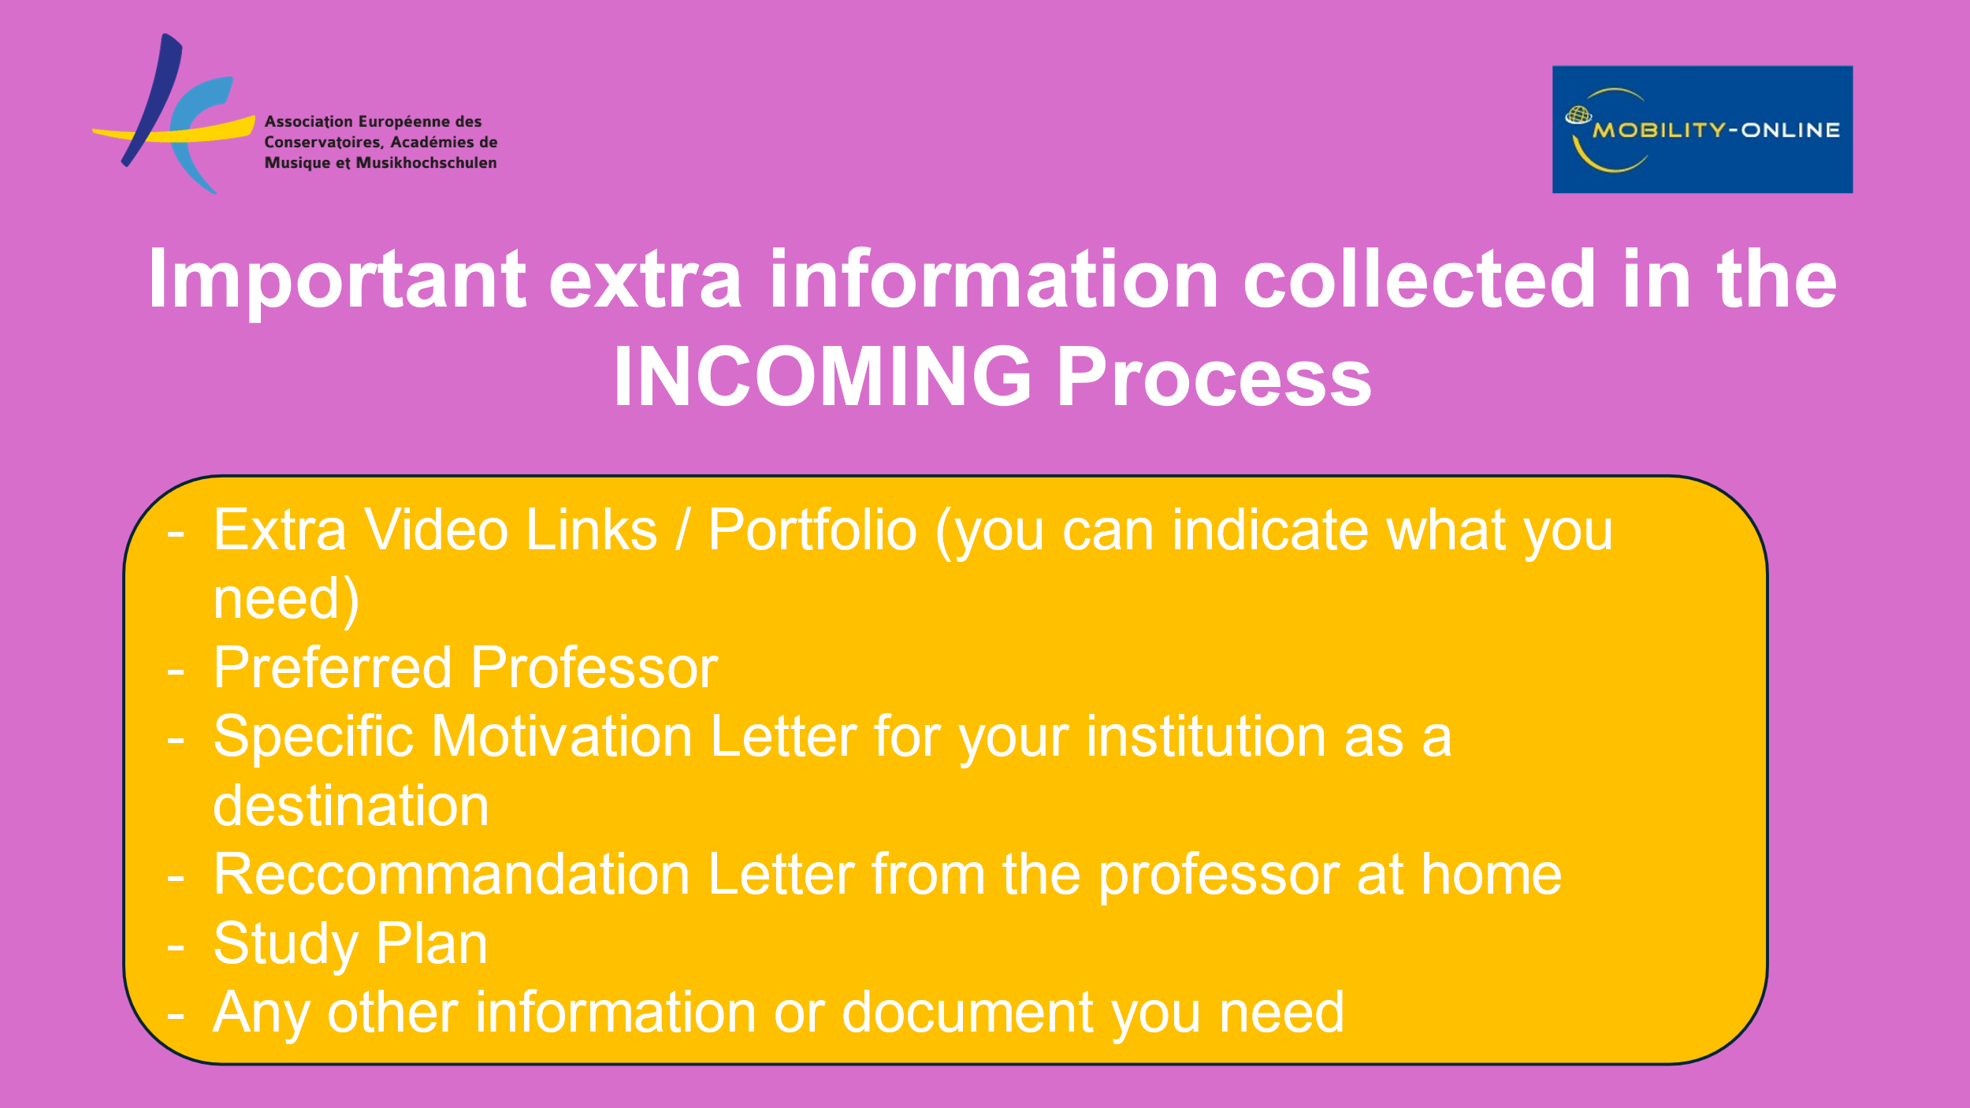

Once the Incoming Coordinator at destination inputs their decision in the system (accepted / rejected) you will receive the decision via email. The decision can be a rejection or an offer of a study place. If you are offered a study place, a deadline to accept or reject will be indicated in the email.

At this point you need to login in the Outgoing or Incoming workflow to accept or decline the offer.

You can now accept or decline the study place in the Workflow (link on the right):

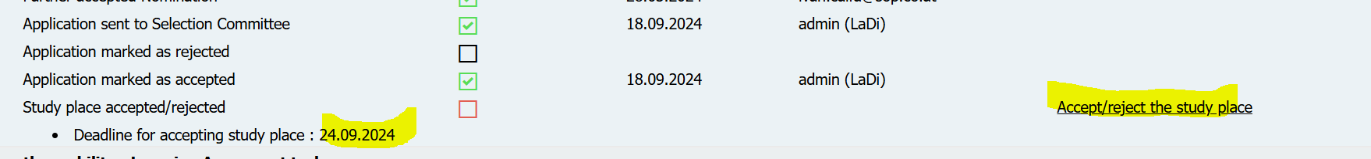

After clicking on the action link of the acceptance/rejection, you need to select “I accept the study place” and click on the button Update.

Both coordinators at home and destination are notified by email regarding your decision, which is still reversable at this point.

If you are waiting for the result of the application to various destinations but you do not want to miss the deadline of a destination you have been already offered a study place from, you can accept their offer by the deadline and then change your decision in the system at a later point.

However, at some point your home coordinator will ask you if the last decision you input in the system is your final one. You will need to confirm your final decision / destination in the Outgoing Workflow.

At this point, you home coordinator will allocate you to your final choice and launch the Learning Agreement procedure.

**Learning Agreement**

The Learning Agreement is the official document that certifies the terms of your mobility, describes the official starting and finishing dates, the courses you are going to take abroad and their correspondence at your home institution and many other important details.

If your home institution manages Learning Agreements within EASY MO, after your home coordinator has allocated you to your final destination you will need to go to your Outgoing Workflow, and the links about entering information and entering courses in the Learning Agreement will now appear.



The Learning Agreement needs to be signed by you, a representative of your home institution and a representative of your destination. You are the first one filling in and signing the document.

In the first step of the workflow related to the Learning Agreement, by clicking on “Enter Information” you will be asked to fill in the **start and ending dates** (that you can take from your acceptance letter ) and language competences

The following two steps are about filling in **courses at the host** institution and **courses at the home** institution. All the other data are automatically populated from the application. To add the courses you need to click on ***Enter further courses...***

(grey fields are optional)

Once saved, the courses will appear as follows

It is preferable that the student has already agreed with the coordinator/s on a list of courses to insert in the DLA, their official names, codes, and number of credits, and the corresponding courses at home. When the list of courses is complete, you can click on Final check before signing

You now have the overview of the Learning Agreement (you need to scroll down to see the full document).

You can now sign by clicking on the button **Sign and Transfer**

The document is now transferred to the home coordinator first and host coordinator for their signatures. If the document is good as it is, they will sign it and you will receive notifications about it. If they want to apply any changes to the document, they will reject it with a note saying what you need to change. You will receive a notification about it. In this case, you will need to enter again your Outgoing Workflow, apply changes, and sign and transfer again. The two coordinators will receive again the document for signature.

The history of the document can be reviewed by clicking on the button Timeline.

You can still apply changes to the document during your mobility.