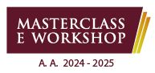

Mgr. Ivana Jurčo, PhD. / Mgr. Dominika Sondorová, PhD.

*Slovac folk culture and music*

25 - 28 novembre 2024

Scadenza iscrizione: 23/11/2024

l/la sottoscritto/a______________________________________________nato/a il ______________

a_________________________________________residente a_______________________________

in via/piazza________________________________________________________________________

e-mail_____________________________________________tel._____________________________

CHIEDE

di partecipare al workshop in oggetto.

Data Firma